Mobile Development Project

Documentation

# INDEX

Description ……………………………………………………………………………………… 1

Requirements .…………………………………………………………………………………... 1

Handeling errors ………………………………………………………………………………… 4

Running the app ………………………………………………………………………………… 4

# Description

This program is a banking app where users can sign up for an account, the user then gets a savings and cheque account. The user can transfer money from each account to another as long as there is sufficient funds. R100 is deposited into the savings account upon successfully signing up for testing purposes. The user can also view their profile and each of the accounts in more detail. The user can sign out and will be required to login again.

To run the application you will need Windows operating system, because the program used to build it is VIsual Studio 2019

# Requirements for Visual Studio 2019

In the installer of Visual Studio 2019 you will need to select the following:

Web & Cloud:

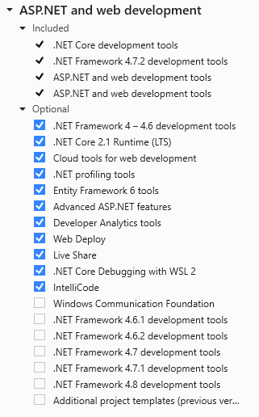

Desktop and Mobile:

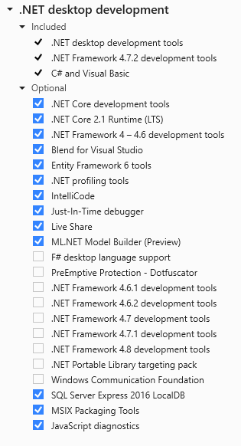

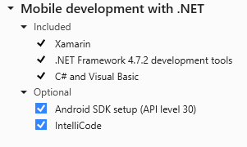

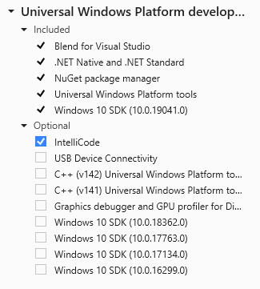

You will also need an android emulator or you can use a physical android or iOS device when using an android device you will need to enable usb debugging in developer options and when using an iOS device you will have to install iTunes on the computer you’re using.

# 

# 

# 

# 

# 

# Handeling Errors

The most common error is:

“error : The project file cannot be opened. Version 7.0.201 of the .NET SDK requires at least version 17.4.0 of MSBuild. The current available version of MSBuild is 16.11.2.50704. Change the .NET SDK specified in global.json to an older version that requires the MSBuild version currently available.”

To deal with this error you can download an earlier version of the .Net SDK or you can run the project on Visual Studio 2022 and you will be prompted to download the missing requirements or you will get a link in the terminal to download missing requirements.

# 

# Running the app

To run the app the app open VIsual Studio and open the project folder, once it is open on Visual Studio run the solution (SisonkeBank.sln). You should have 3 projects loaded, if you’re using either an android device or android emulator, right click on the SisonkeBank.Android project and select *Set as Startup Project* if you’re using an iOS device then do the same but on the SisonkeBank.iOS project. Click the green play button to run the app. When using an iOS device a wizard will guid you to connecting your device, follow the instructions until your device until is connected

The values to enter are specified in the app. If a value entered is not valid the user will get notified and will not be allowed to continue.

When running the app should look like this:

